Chapter 16, Problem 55.

Obtain i₁ and i₂ for t > 0 in the circuit of Fig. 16.78.

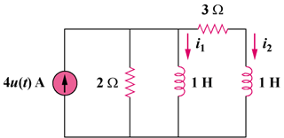

Figure 16.78
For Prob. 16.55.

